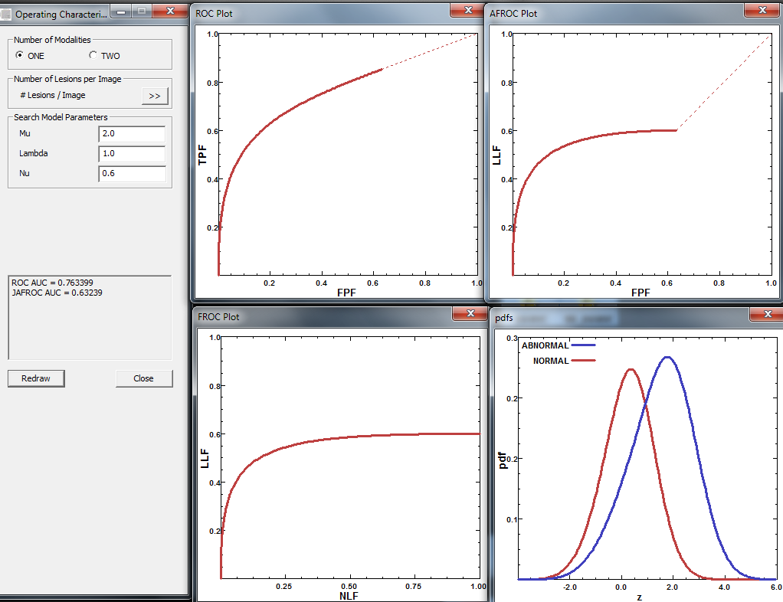bounding window
Left panel should be at top; wasting lot of space
JAFROC Weighted: this follows the 2004 Medical Physics definition. The "weights" are picked up from Truth sheet or method defaults to equal weighting if entries are zeroes; must use Excel input format for this analysis.

Reporting to file: C:\Users\Dev1\Dropbox\Vortex\DataAndRawResults\LesionLevelAnalysis\ExcelDataFiles\CTVisible\JAFROC_input_3mm_to_4mm_Song_A1_AUC.txt
Etc.

Need to fix sens and spec code for A1; for A2 only AUC is allowed

ROI message missing;

Sample size calculator for data file is messed up;

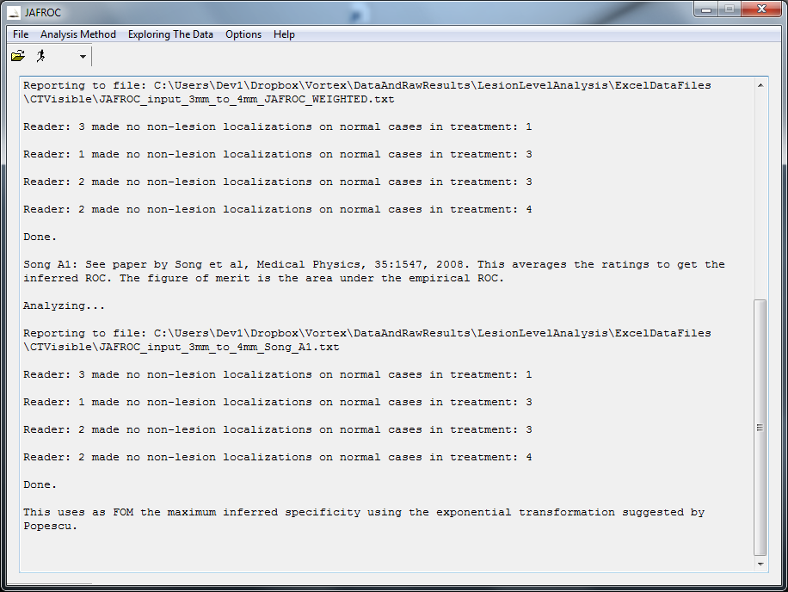

Improvements
Should print full path name of data file to report file right now it does not;
Datafile: C:\Users\Dev1\Dropbox\Vortex\WhatToDoWhatIsDone\ActionabilityAnalysis\input_actionability_ROC_new.xlsx
Input Data Filename : input_actionability_ROC_new.xlsx
I found a situation where it is printing the incorrect path to the file; I will have to show you tomorrow; dev
One more inconsistency: upon file open it shows via a pop-up the analysis that will be done but does not echo to the command window; the command window should have a history of everything that was done; thanks; and remember, I am trying to improve the code beyond when you got here; thanks; dev
Opening window should be re-sizeable, etc.
One more inconsistency: upon file open it shows via a pop-up the analysis that will be done but does not echo to the command window; the command window should have a history of everything that was done; thanks; and remember, I am trying to improve the code beyond when you got h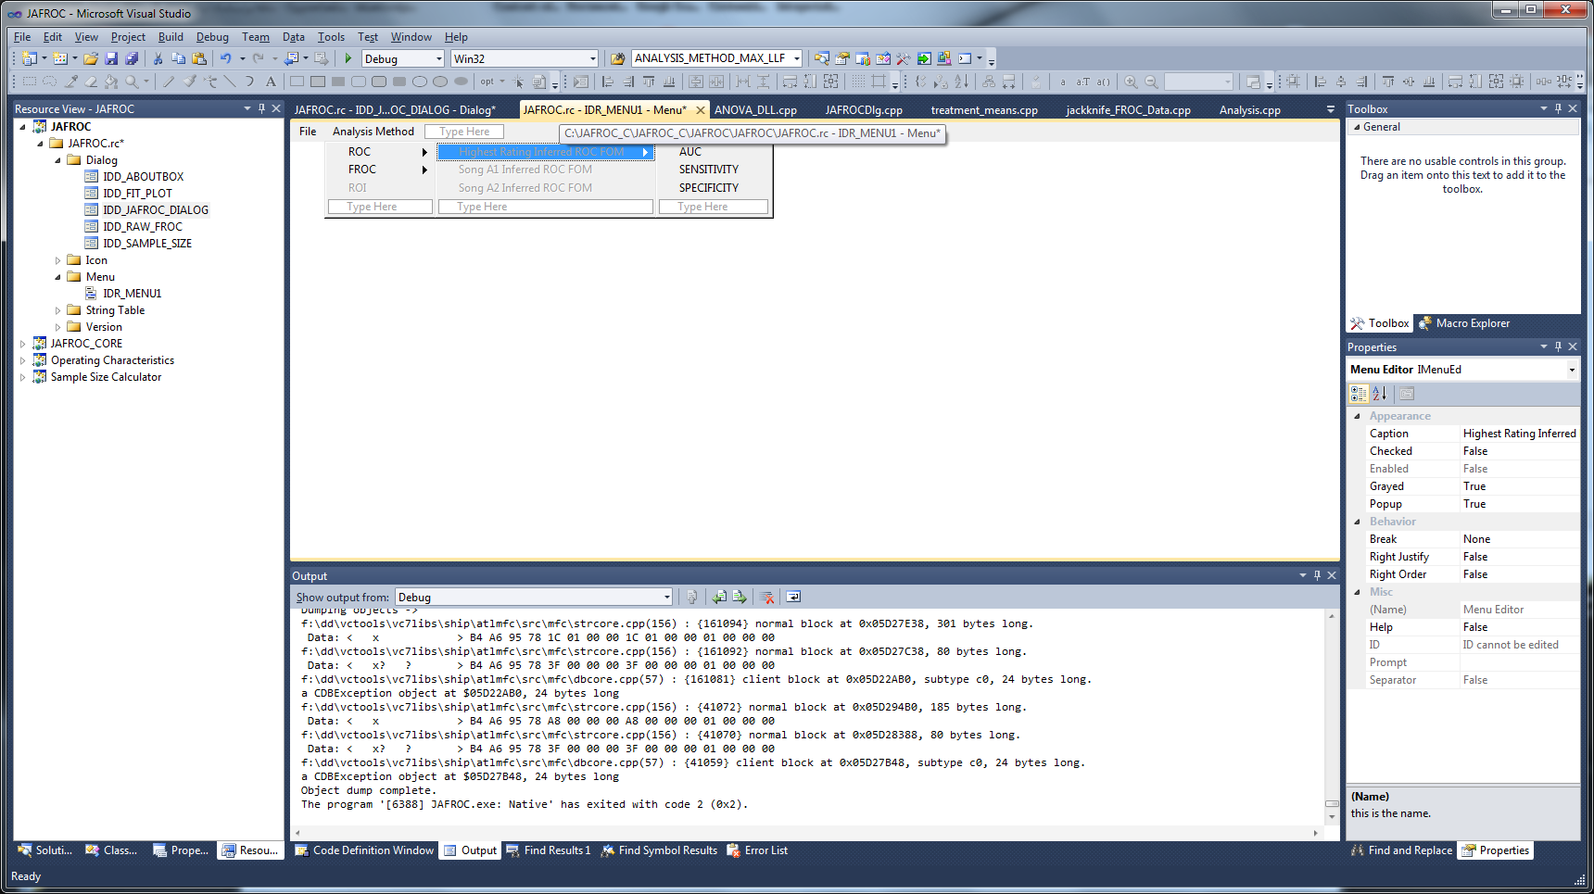ere; thanks; dev
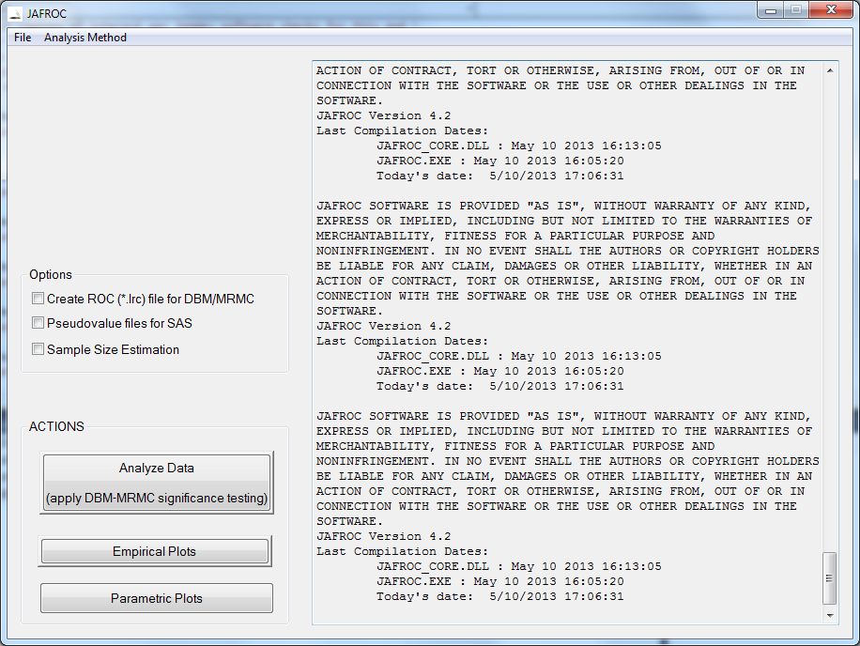

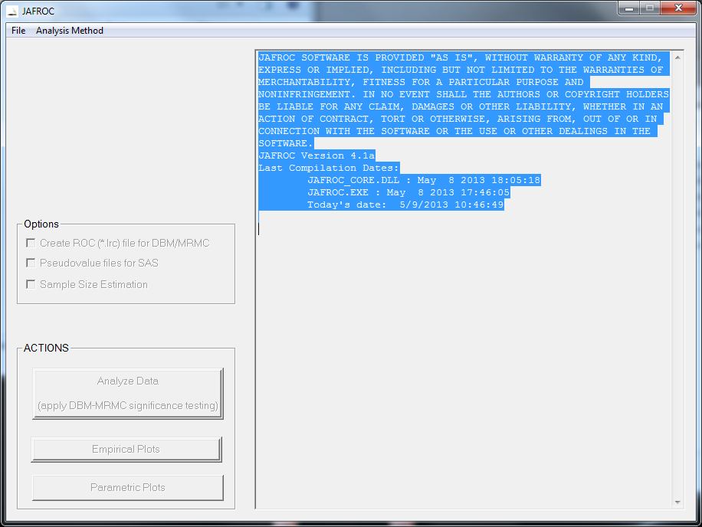
- File Menu
  - Select Data File: hovering message: select appropriate data file
  - Exit
- Analysis method hovering message: select appropriate figure-of-merit (FOM)
  - ROC
    - Highest rating inferred ROC FOM
    - Song A1 inferred ROC FOM
    - Song A2 inferred ROC FOM
  - FROC
    - JAFROC1
    - JAFROC1 weighted
    - JAFROC2
    - JAFROC2 weighted
    - Lesion Specific Analysis
    - TBA
  - ROI: hovering message: data file is not appropriate to ROI analysis (only if…..)
- Exploring the data
  - Plotting based on selected data file
    - Empirical plots
    - Parametric plots
  - Plotting based on user specified search model parameter values
  - Sample size calculator based on selected data file (currently option sample size estimation)
  - Sample size calculator based on user specified values (pull up the current calculator)
- Options (not exclusive)
  - Create….
  - Pseudovalues…
- Help
  - Help (link to website)
  - About JAFROC
    - Version #
    - Last compilation date etc.

Comments
- Hovering…; show what the selection will do even before it has been selected
- Run button with picture of person running

